Home Server Remote Access - RustDesk Direct IP
Secure LAN Remote Desktop · Direct IP Access · Windows Firewall · Troubleshooting Log
Oct 13, 2026 · @MrBSykes
Item | Detail
Project Title | Home Server Remote Access: RustDesk Direct IP
Date | October 13, 2026
Analyst | Bryan Sykes
Platform | Windows home server (sykeshomeserver) and a Windows client machine
Remote Access Tool | RustDesk desktop client
Connection Method | Direct IP access over the LAN, TCP 21118, no relay server
Execution Environment | PowerShell and Windows Firewall on the server; RustDesk on both machines
GitHub | github.com/MrBSykes
Coverage | Business problem, architecture, implementation walkthrough, troubleshooting log, business alignment

1. The Business Problem
Remote support is only as reliable as the path between the technician and the machine. Help desk and IT support staff constantly need to reach systems they are not sitting at: servers, user workstations, lab machines. Remote desktop tools make that possible, but when the connection depends on infrastructure you do not control, access can disappear without warning.
That is what happened here. Connecting to the home server by RustDesk ID through the free public relay failed with a "connection is not allowed" error and a prompt to log in. The public server now requires a login because of scam and botnet abuse, and its operators describe it as a demo and testing service, not something to use for production or sensitive work. Three problems follow from relying on it:
- Third-party dependency: access can be restricted or withdrawn at any time, as this error showed.
- Exposure: sessions through a shared public relay are a poor fit for a home server that holds lab data.
- Reliability: a self-hosted relay (hbbs/hbbr in Docker) was tried first and never connected, so a simpler path was needed.
Direct IP access removes the relay entirely. The client connects straight to the server's LAN address, with no account, no third party and nothing leaving the network.

1.1 Real-World Applicability
Scenario | Without a controlled access path | With direct IP access
Vendor restricts a free service | Support sessions stop until a workaround is found | Connection path is unaffected
Support session to an internal server | Traffic crosses a third-party relay | Traffic stays on the LAN
Reviewing who can reach a machine | Shared infrastructure, unclear exposure | One firewall-scoped port plus a password
"I can't connect" ticket | Trial and error | Layered checks: listener, firewall, client path
Onboarding a new technician | Tribal knowledge | A written runbook

2. Architecture
The final design is one direct TCP connection between two machines on the same network, with the public relay out of the path.

2.1 Connection Topology
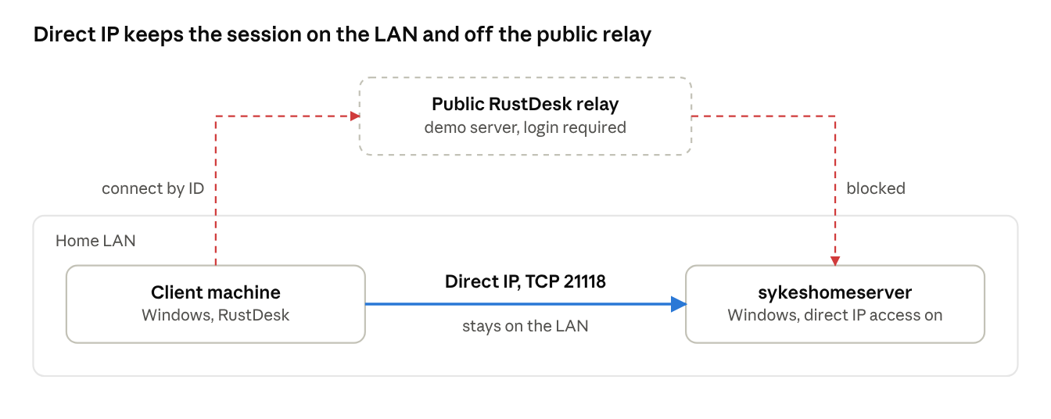
connection paths · 1 working, 1 blocked
The dashed red route is the original connect-by-ID attempt through the public relay, which now requires a login. The solid route is the direct IP session that works.

2.2 Security Design Principles
- Least exposure: one inbound port (TCP 21118), allowed in Windows Firewall, with no router port forwarding, so it is reachable from the LAN only.
- No third party in the path: no relay and no account sits between the two machines.
- Authenticated sessions: a password is required to connect, and a permanent password replaces the one-time one.
- Public relay kept out of sensitive work: this follows the operators' own guidance that the public server is for demos only.
- Outside access deferred: reaching the server from outside the home waits for a mesh VPN such as Tailscale, not opened ports.

3. Implementation Walkthrough
The working setup is four steps on the server and two on the client. The one rule that matters: connect by IP address, never by RustDesk ID, because an ID connection goes through the public server and hits the login block again.

3.1 Server (sykeshomeserver)
- Open RustDesk, go to Settings, then Security, and click Unlock security settings.
- Turn on Enable direct IP access.
- Allow inbound TCP 21118 in Windows Firewall, from an admin PowerShell:
New-NetFirewallRule -DisplayName "RustDesk Direct" -Direction Inbound -Protocol TCP -LocalPort 21118 -Action Allow -Profile Any
- Set a permanent password under Settings, then Security, so access does not depend on the one-time password.

3.2 Client
- In the "Control Remote Desktop" box, enter the server's LAN IP address (for example 192.168.1.x).
- Click Connect and enter the permanent password.

3.3 Verification Commands
Run these when a connection fails, in order. Each one isolates a single layer.
# On the server: is anything listening on the direct IP port?
netstat -an | findstr 21118
# On the client: can it reach that port?
Test-NetConnection <SERVER_LAN_IP> -Port 21118
No listener means direct IP access is not actually enabled. A listener but a failed Test-NetConnection points to the firewall, router client isolation, or a different subnet.

3.4 Display Tuning
The first session showed black bars and a shrunken desktop. These session settings address it:
- Switch to fullscreen from the session toolbar.
- Set View Style to Scale adaptive (fits the window) or Original (1:1 pixels, scrolls).
- Set Image Quality to Best, since a LAN has plenty of bandwidth.
- If text is still small, lower the display resolution on the server.

4. Components and Status
Direct IP access is the one path that works; both relay-based options were set aside.
Component | Detail | Status
Public RustDesk relay | Connect by ID through the demo server | Blocked, login required
Self-hosted hbbs/hbbr in Docker | Own relay on the home server | Abandoned after repeated connection failures
Direct IP access on sykeshomeserver | RustDesk setting, TCP 21118 with a firewall allow rule | Working
Client session display settings | Fullscreen, view style, image quality | Tuned
Permanent password | Replaces the one-time password | Recommended
DHCP reservation for the server | Keeps the saved LAN address valid | Planned

5. Troubleshooting Log
Four issues came up. Each is recorded with its root cause (or an honest note where it was not isolated) and the lesson a support team would carry forward.

Issue 1: Public Server Login Required
Field | Detail
Symptom | Connection error: the connection is not allowed, and the user must log in before connecting
Root Cause | The RustDesk public server now requires a login because of scam and botnet abuse, and is meant for demos only. The client was still pointed at it, as the status bar prompt to set up your own server showed.
Resolution | Stopped relying on the public relay and moved to direct IP access
Business Lesson | Free third-party services change their terms without notice. Do not build a support workflow on a service that is explicitly demo-only.

Issue 2: Self-Hosted Relay in Docker Would Not Connect
Field | Detail
Symptom | Repeated failed connections using hbbs and hbbr containers on the home server
Root Cause | Not isolated. Common causes for this setup are UDP 21116 not published, a missing or wrong public key on a client, and no relay address set on hbbs.
Resolution | Dropped the Docker route and used direct IP access instead. A native Windows hbbs/hbbr install is a follow-up.
Business Lesson | Choose the simplest architecture that meets the requirement, time-box the complex one, and record honestly what was not diagnosed.

Issue 3: Direct IP Connection Failed at First
Field | Detail
Symptom | Connecting by IP address failed on early attempts
Root Cause | Not recorded at the time. Candidates checked: direct IP access not enabled (no listener on 21118), a firewall blocking 21118, or an ID typed where an IP belongs.
Resolution | Worked through the layered checks (netstat, then Test-NetConnection), after which the session connected
Business Lesson | Test one layer at a time: listener, firewall, then client path. Random setting changes hide the cause.

Issue 4: Compressed Remote Display
Field | Detail
Symptom | The remote desktop appeared small with black bars on both sides
Root Cause | The server's screen shape and resolution differed from the client window, and the default view style scaled the image down to fit
Resolution | Went fullscreen, changed the view style, and set image quality to Best
Business Lesson | A connection that works is not yet a usable support session. Tune the display before handing it to a technician.

6. Business and Career Alignment

6.1 Help Desk and Federal IT Relevance
Remote desktop sessions are daily work on a help desk or service desk, and the technician who understands what sits underneath one (ports, firewalls, relay versus direct paths) can fix a "can't connect" ticket instead of escalating it.
- Service desk and Tier 1 support: the troubleshooting sequence here (listener, firewall, client path) is the same sequence used on real connectivity tickets.
- Federal contracting: NIST 800-53 control AC-17 (Remote Access) expects remote access methods to be documented, authorized and restricted. A single named port, a password and a written runbook support that.
- Least exposure: the final design keeps traffic on the LAN with no router port forwarding and no third-party relay.

6.2 Skills Demonstrated
Skill | Evidence in This Project
Remote support tooling | Configured and tuned RustDesk sessions between two Windows machines
Windows networking and firewall | Created an inbound rule for TCP 21118 in PowerShell and checked listeners with netstat
Structured troubleshooting | Isolated the listener, firewall and client path with netstat and Test-NetConnection
Reading error messages | Interpreted the public server's login block and chose a different design
Documentation | This write-up, including a troubleshooting log with business context

6.3 Certification Alignment
Certification | Relevance to This Project
CompTIA Security+ (earned) | Secure remote access, least exposure, avoiding a public relay for sensitive work, port and firewall rules
AZ-104 (next) | Azure Bastion, planned in the Azure project, solves the same secure-remote-access problem in the cloud

7. Next Steps
Action | Purpose
Reserve a fixed IP for the server in the router | Keep the saved LAN address valid after reboots
Add Tailscale to both machines | Reach the server from outside the home network without port forwarding
Rebuild the self-hosted relay natively on Windows | Finish the path that failed in Docker and find its real root cause
Run hbbs and hbbr as Windows services | Make the relay survive reboots if it is rebuilt
Publish this write-up with the README on GitHub | Add it to the home lab portfolio

8. Conclusion
This project treated a blocked third-party service as a design input, not a dead end. Direct IP access over the LAN gives remote desktop access to the home server with no account, no relay and no exposed internet port.
The problems along the way were ordinary support work: an error message that explained its own cause, a complex path abandoned for a simpler one, and a connection fault narrowed down one layer at a time. Diagnosing and documenting them is the job.

